Work instruction — air compressor preventive maintenance
Document no. | WI-MNT-014 | Revision | 1.0
Title | Air compressor — routine preventive maintenance | Effective date | 22 / 09 / 2026
Equipment / area | Reciprocating air compressor, 7.5 kW, 270 L receiver | Department | Maintenance
Frequency | Every 500 operating hours or 6 months | Page | 1 of 1

PPE and safety
Safety glasses, gloves and hearing protection. Compressed air and stored energy are present: isolate the machine and verify zero pressure before any work, following the site lockout/tagout procedure.

Tools and materials
Padlock and tag · drain pan · compressor oil to the nameplate grade · replacement intake filter element · 13 mm spanner · clean lint-free cloth.

Service points
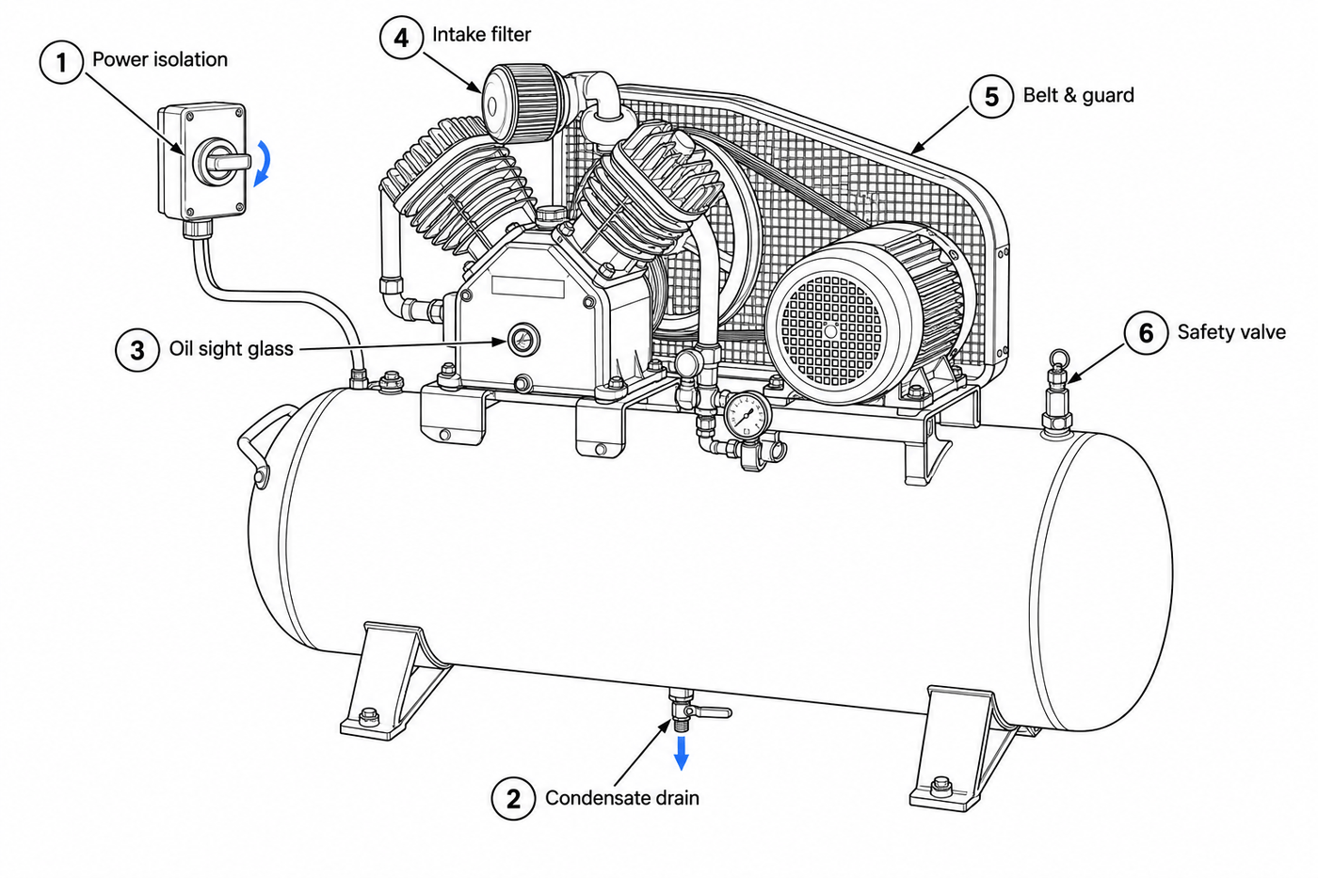
Routine service points referenced by the steps below

Procedure
Step | Operation | Key points / acceptance
1 | Switch the compressor off at the wall isolator and fit a padlock and tag. Close the outlet ball valve. Confirm the receiver gauge reads 0 bar before going further. | Key point: Do not rely on the pressure switch alone to isolate the machine.  Accept: Isolator locked and tagged; gauge reads 0 bar.
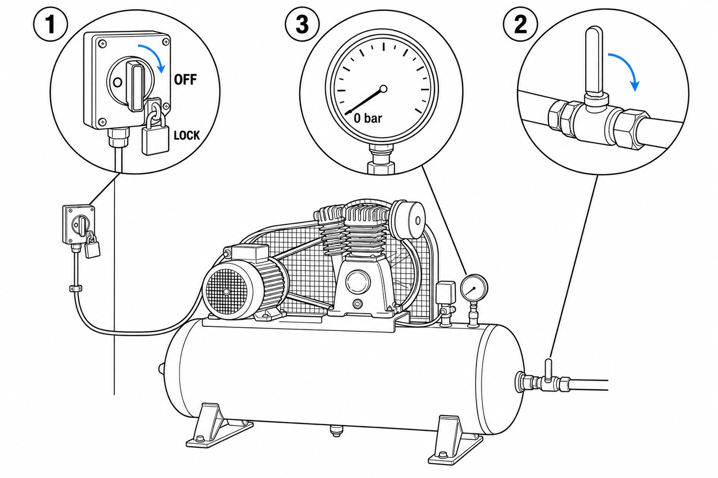
Figure 1 — Isolator locked off, outlet valve closed, gauge at zero

Step | Operation | Key points / acceptance
2 | Place the drain pan under the receiver. Open the drain valve fully and let the condensate discharge until only air escapes, then close the valve. | Key point: Drain only with the tank at zero pressure.  Accept: No liquid remains; drain valve closed.
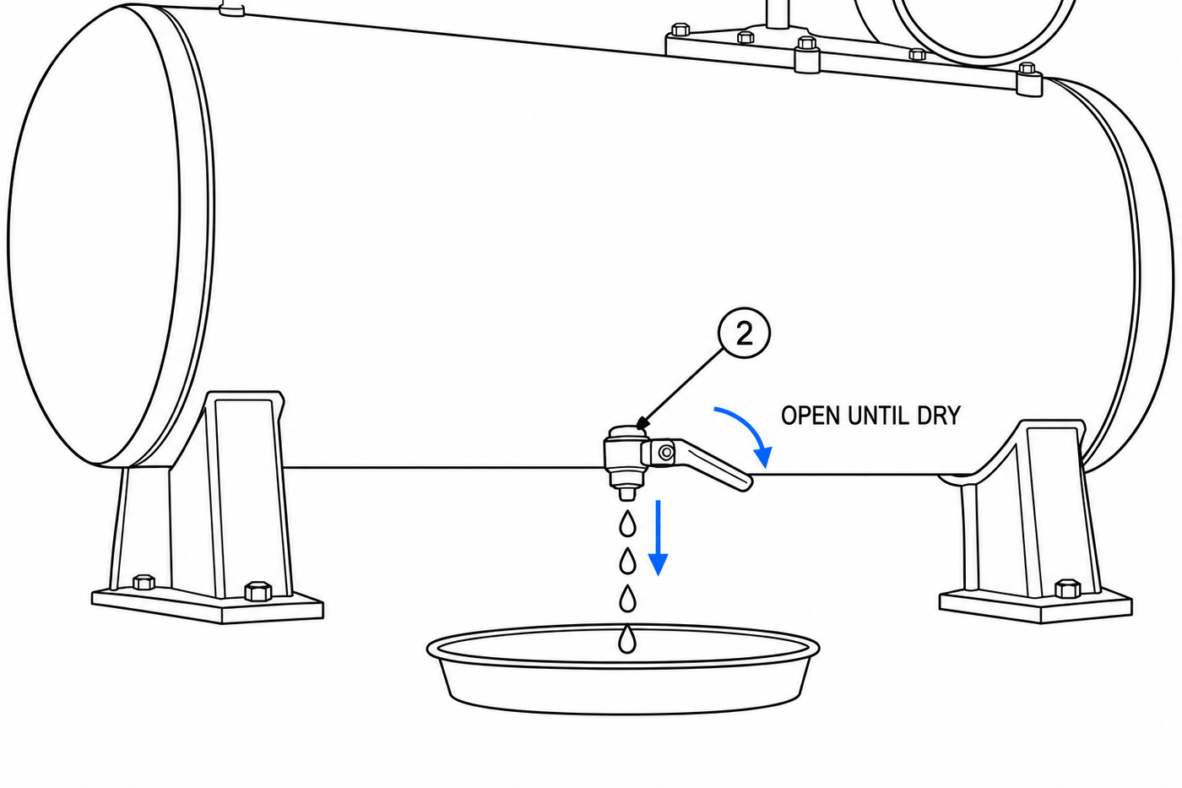
Figure 2 — Condensate drained from the bottom of the receiver

Step | Operation | Key points / acceptance
3 | Read the crankcase sight glass. The level must sit between MIN and MAX. If low, top up through the fill port with the grade given on the machine nameplate. | Key point: Do not overfill above MAX; excess oil carries over into the air line.  Accept: Level between MIN and MAX; fill cap refitted.
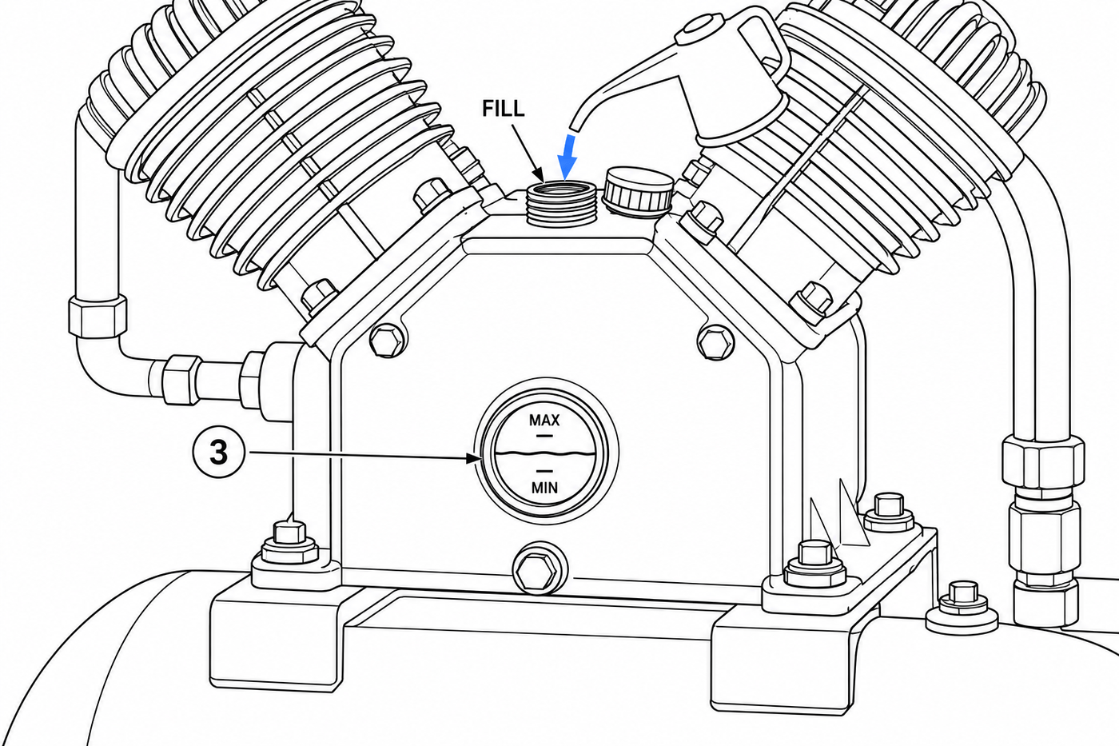
Figure 3 — Oil level read against the MIN and MAX marks

Step | Operation | Key points / acceptance
4 | Unscrew the wing nut, lift the cover and withdraw the element. Replace it if it is discoloured or clogged. Refit the cover and tighten the wing nut by hand. | Key point: A clogged element raises running temperature and oil carryover.  Accept: Clean element fitted; cover secure.
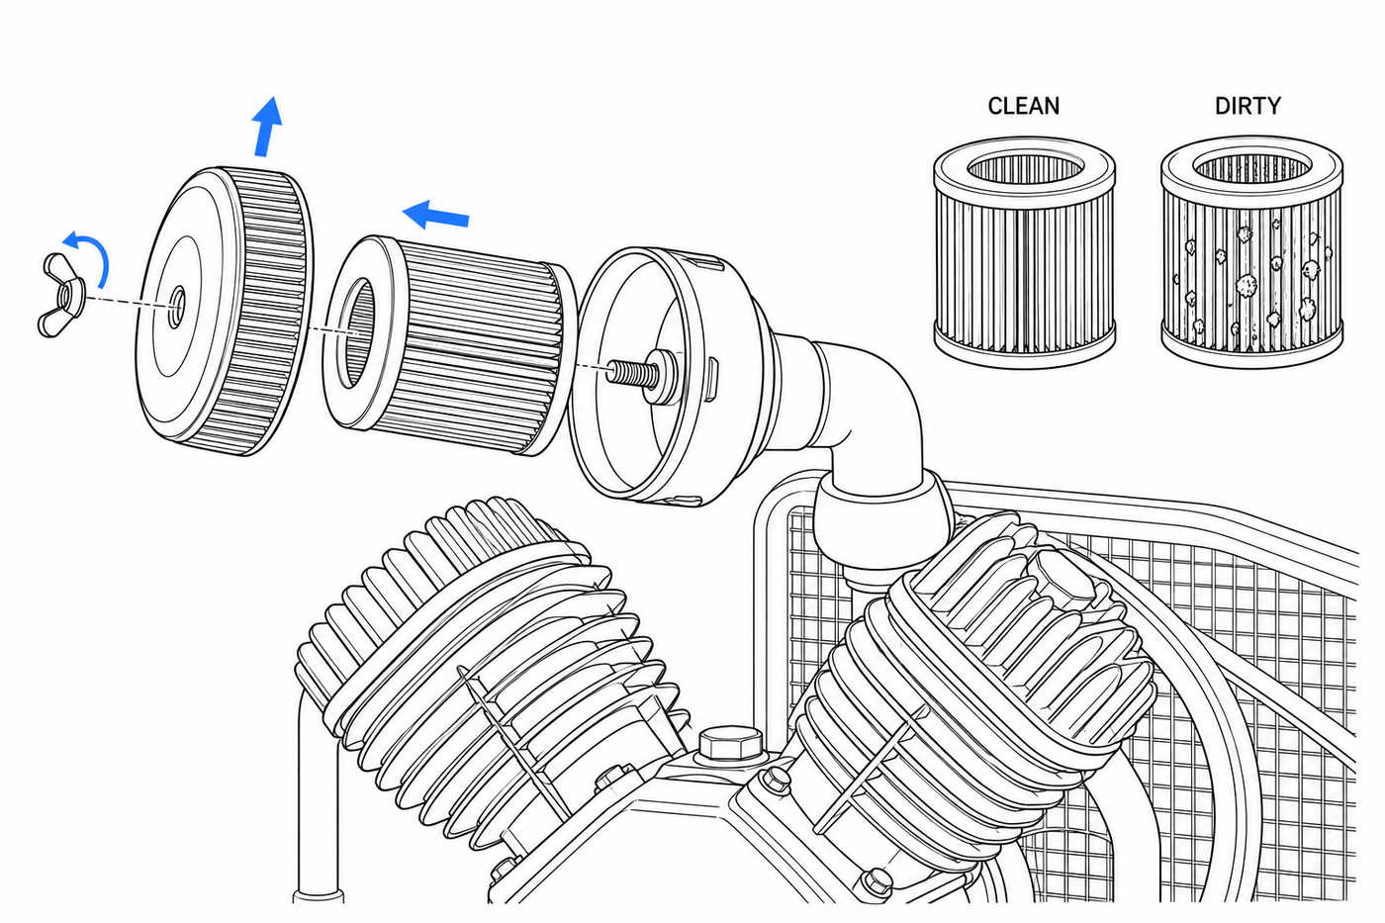
Figure 4 — Intake filter element withdrawn, clean against clogged

Step | Operation | Key points / acceptance
5 | Remove the belt guard. Press the belt at mid-span with moderate thumb pressure; deflection should be about 13 mm. Adjust the motor slide rails if it is outside tolerance, then refit the guard. | Key point: Never run the compressor with the belt guard removed.  Accept: Deflection approximately 13 mm; guard refitted.
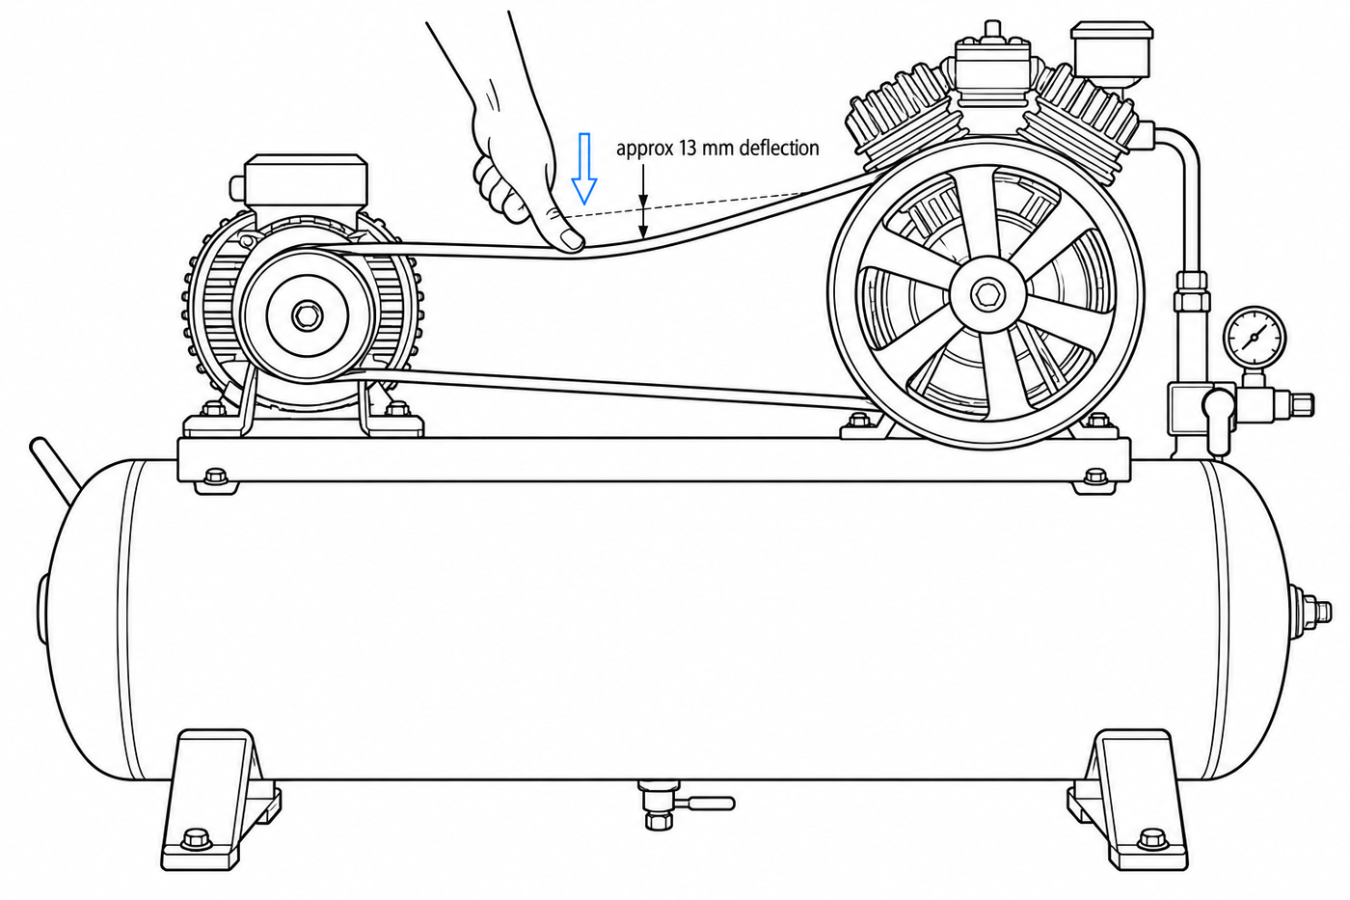
Figure 5 — Belt deflection checked at mid-span

Step | Operation | Key points / acceptance
6 | With the receiver repressurised, pull the relief valve test ring, allow a brief discharge, then release it. The valve must reseat cleanly. | Key point: Stand clear of the discharge path and wear hearing protection.  Accept: Valve lifts and reseats with no audible leak.
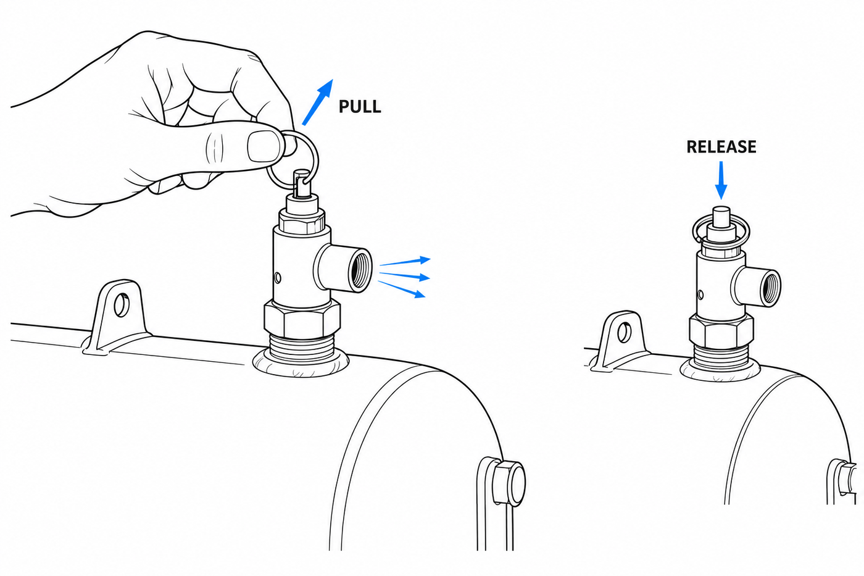
Figure 6 — Relief valve test ring pulled, then released to reseat

Quality check — belt seating
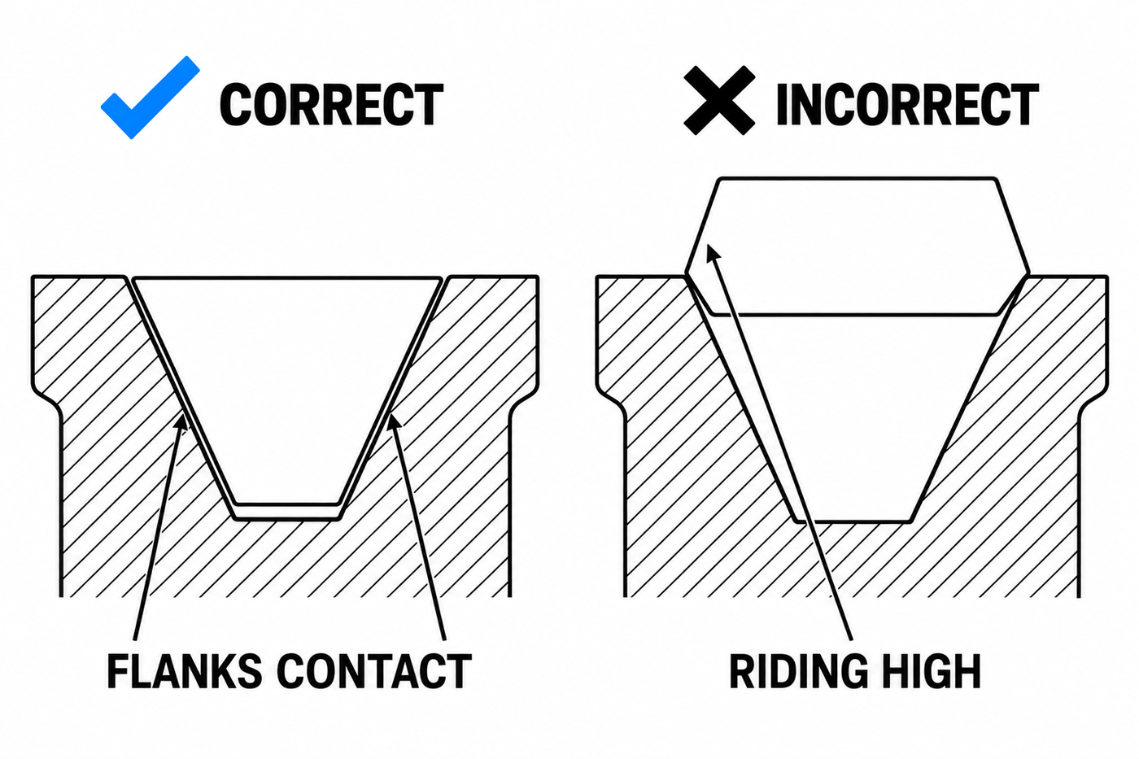
A correctly seated belt against one riding high in the groove

Sign-off
Prepared by | Reviewed by | Approved by | Date

Revision history
Revision | Date | Change | Author
1.0 | 22 / 09 / 2026 | First issue
This document is a layout example produced to show how an illustrated work instruction is put together. It is not a validated maintenance procedure: check every value against your own equipment manual before use.

